FROM AGM

All board members viewed on their mobiles. agreed that logo on landing page should be bigger, change survivors to patients, change wording to ‘ for every R3000 raised ,12 people are helped by CHO.& learn more change to black background with white text to establish uniformity.

Avashna explained details of donor’s logo on website. All agreed that website is user friendly and like the new look and feel.

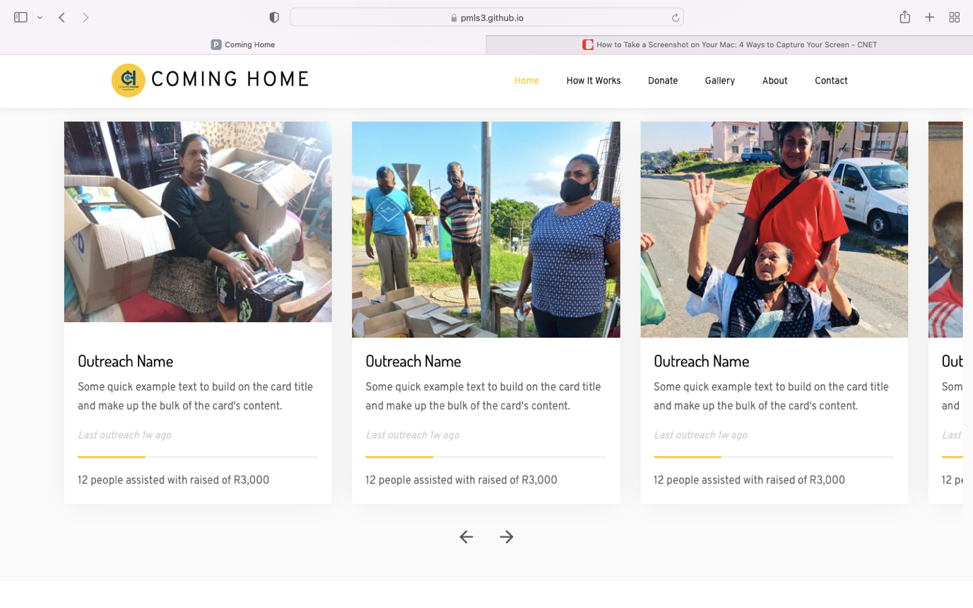

Pic 1:

Ms Ramen, a double amputee patient with her 3 months supply donation of diapers donated by CHO in partnership with Sibaya Community Trust.

Pic 2 :

Some of the recipients of monthly food hamper handouts at Chatsworth community.

Pic 3:

Patient of the year, Tanya Mark picture with CHO volunteer Seetha Govender. Tanya was crowned patient of the year 2022 after the organisation saw her dedication to her recovery despite her circumstances she always thrive to be better.

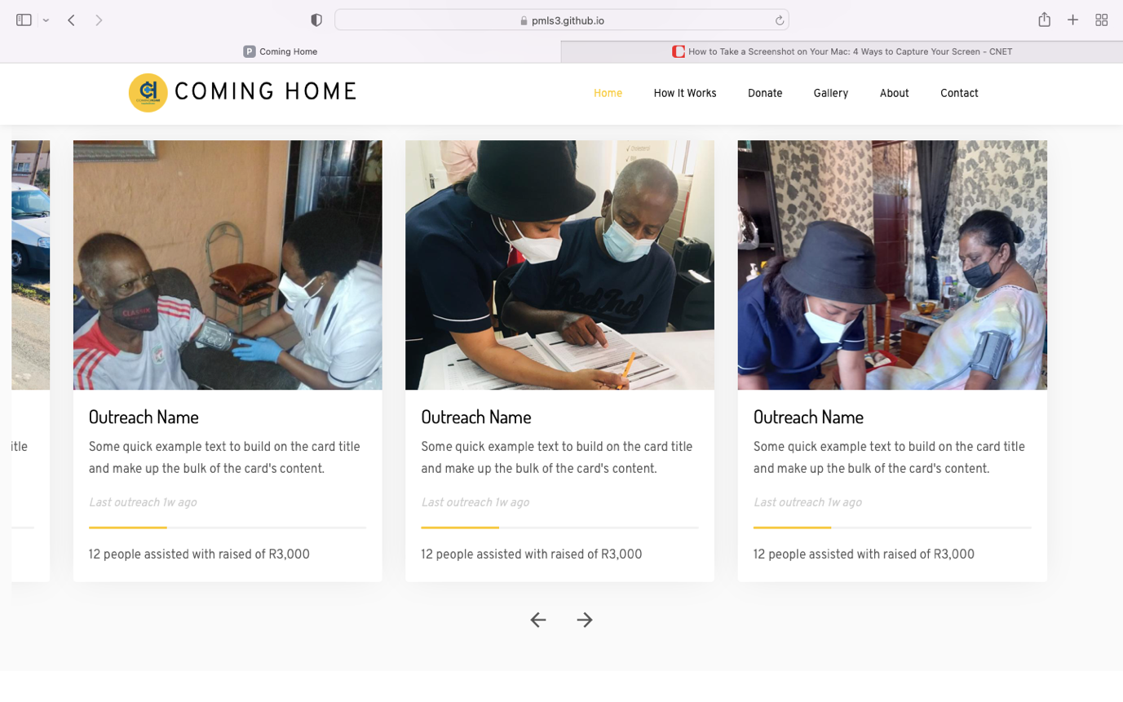

Pic 4

Nurse Prudence picture with Mr Pillay during one of the monthly vital check-up.

Pic 5

Part of CHO’s objective is to give patients holistic approach to help them recover and be able to aid themselves. In the picture caregiver Nombali assisting Mr. Gordon on his diet and living a healthy lifestyle.

Pic 6: please remove this picture and replace it with the one below. Also can you make it the second picture on the slide.

Caption: Mr Mazibuko captured with CHO caregiver Nombali during Newlands Community weekly visit for vital check, home based care and lifestyle and diet advise session.

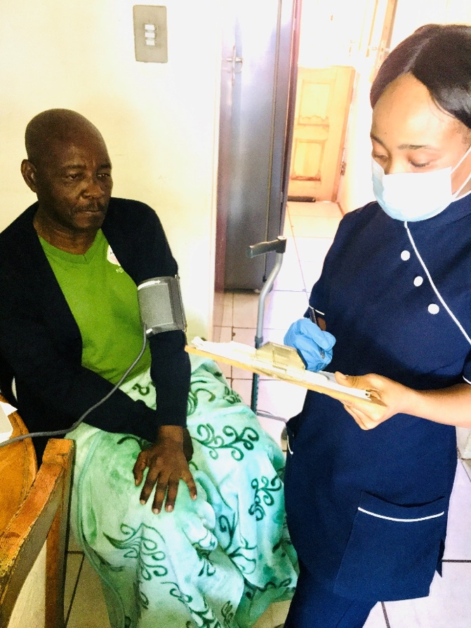

For donors

Please use their logos emailed yesterday, the company name and website only

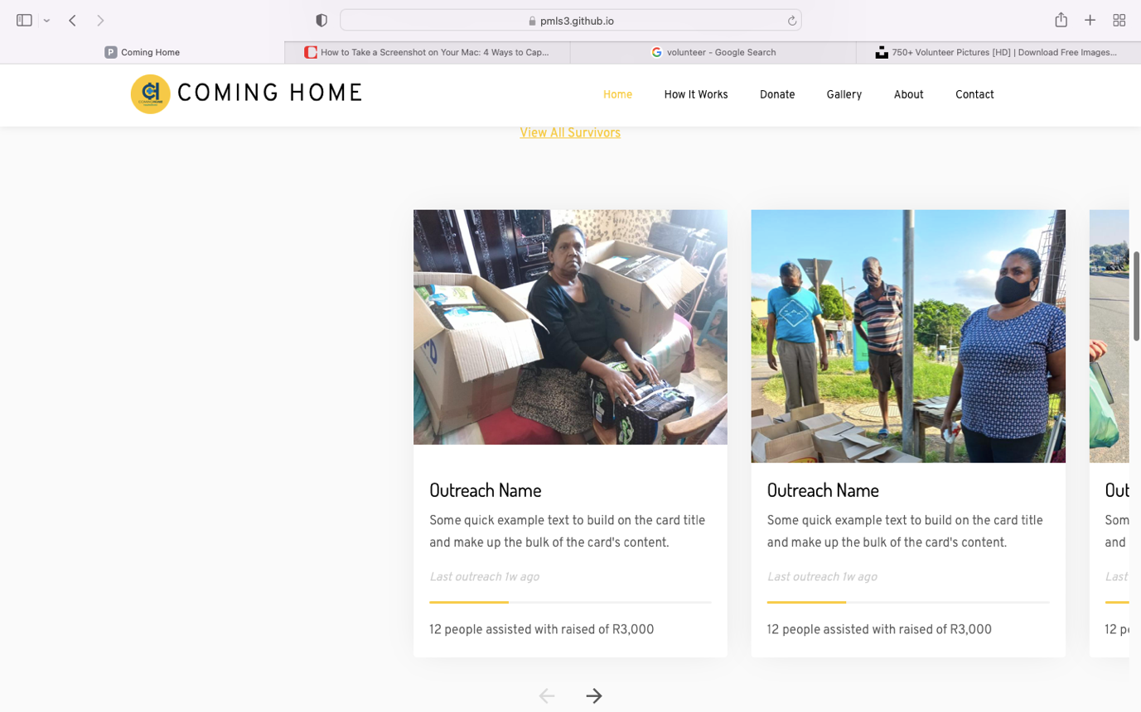



Please use the below picture on about coming home page

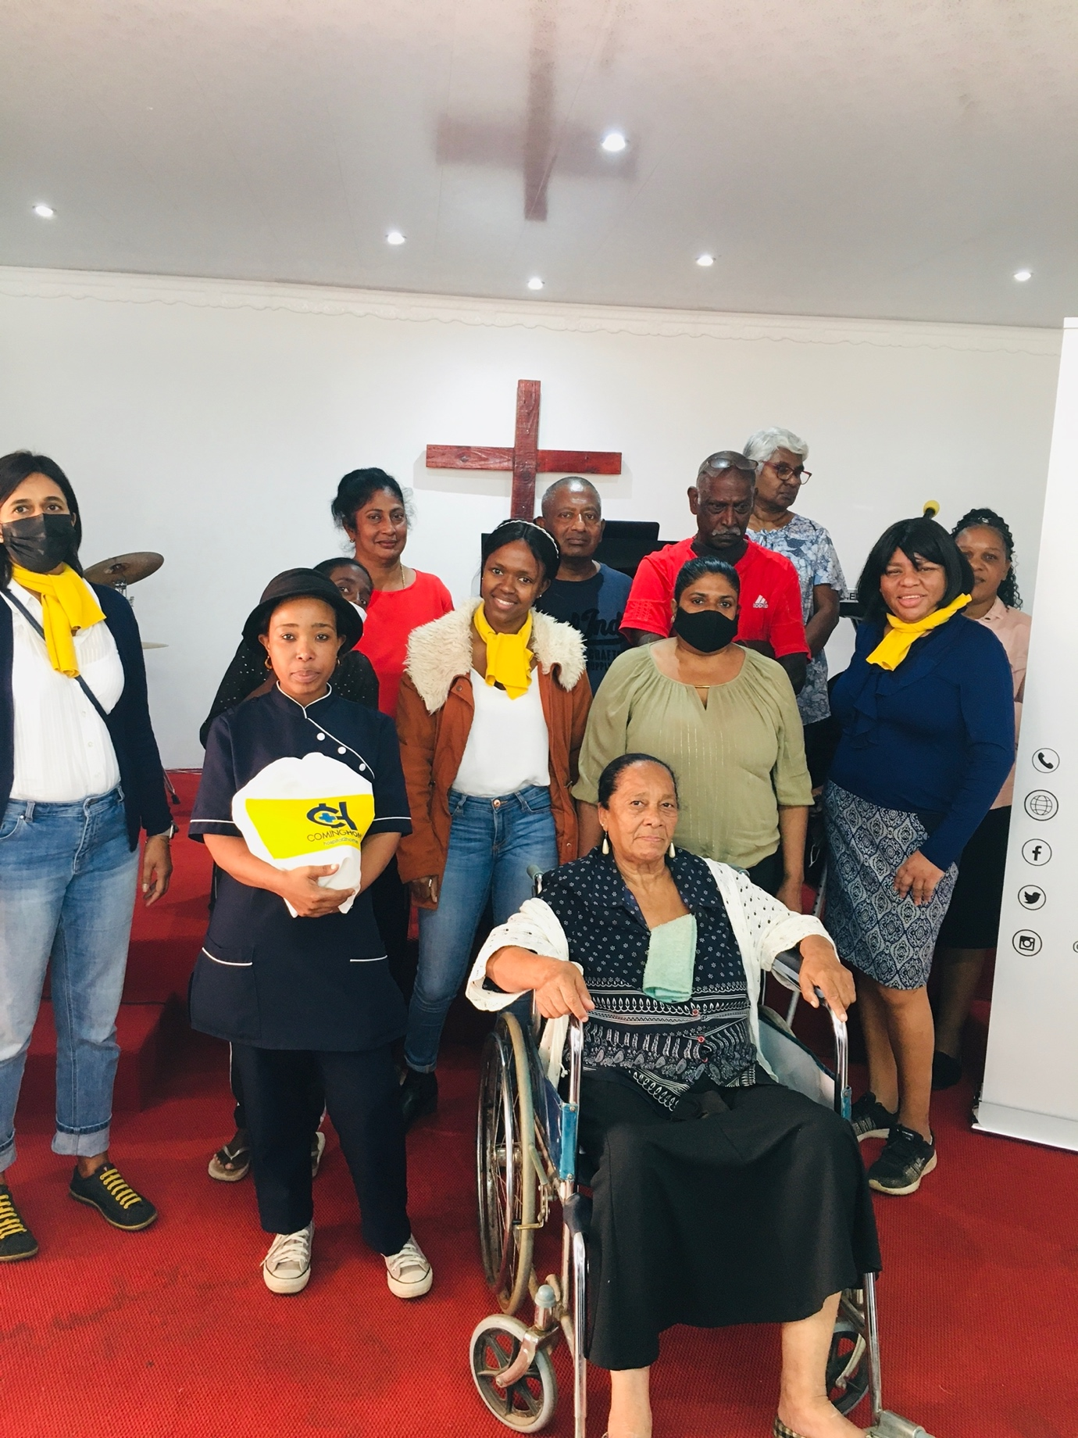

Leadership: staff

Avashna Moodley

Founder and CEO, stroke survivor since 2011

Denise Greeves

Chairperson, stroke surivivor

Khanyi Mdluli

Community Project Manager

Be a volunteer today:

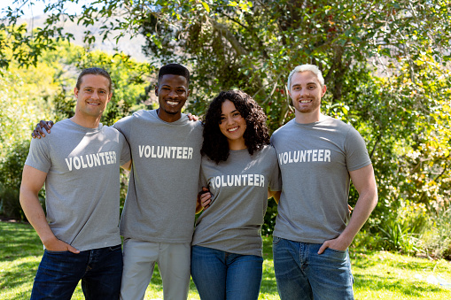

Donate: AVASHNA ADD A PIC

How many people we’ve helped:

Year1: 10 patients

Year2: 18 patients (covid 19 restrictions)

Year3: 80 patients (covid 19 restrictions)

Year4: +40 patients (jan-july)

Overall +140 people have benefited from our services.